Database Homework 4
By: Ryan Riopelle
Sales Cube
Noted: Answers are bolded for each number
## 1)
## Cost with No ID's=
"GroupAggregate (cost=277118.03..330611.22 rows=100000 width=21)"
## Created Customer_ID Index=
"GroupAggregate (cost=277118.03..330611.22 rows=100000 width=21)"
## Created Sales.Index=
"GroupAggregate (cost=277118.03..330611.22 rows=100000 width=21)"
## Cost was not improved by indexes for this step

## 2)
## Cost with no indexes involved
"HashAggregate (cost=91950.93..91953.43 rows=200 width=128)"
## Cost was not improved by indexes for this step

## 3)
# Cost with no indexes
"Sort (cost=37739.03..37739.04 rows=1 width=14)"
#Cost reduced with index placed on the customer ID column of sales
"Sort (cost=8.47..8.47 rows=1 width=14)"
CREATE INDEX index1 ON sales.sale(customer_id);
#I also tried to use other columns for indexes such as sale_id, and product_id
##but neither of these effected the speed
## Cost was not improved by indexes for this step

## 4)
# This query was not effected by indexes
## 5)
##Cost with no indexes
"GroupAggregate (cost=485614.11..518114.11 rows=1000000 width=128)"
# Cost with indexes on sales table product ID
"GroupAggregate (cost=485614.11..518114.11 rows=1000000 width=128)"
#Cost with indexes on the product table
"GroupAggregate (cost=485614.11..518114.11 rows=1000000 width=128)"
# There is no decrease in cost on any of the available indexes here.

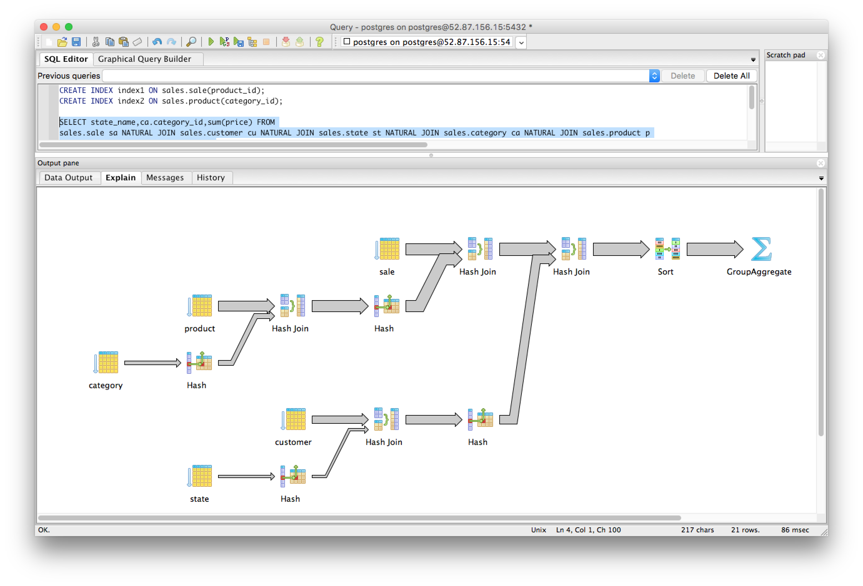
## 6)
##With no indexes involved, cost is the highest
"Sort (cost=206072.90..206073.10 rows=80 width=18)"
##Putting an index on catogory ID did not improve the cost because the number of
## values is larger in the product table
##With index on product_id in sale table, reduces cost
CREATE INDEX index1 ON sales.sale(product_id);
"Sort (cost=175603.68..175603.88 rows=80 width=18)"
##With index on category_id in product table and product_id in the sale table, cost is reduced further
CREATE INDEX index2 ON sales.product(category_id);
"Sort (cost=168252.13..168252.33 rows=80 width=18)"

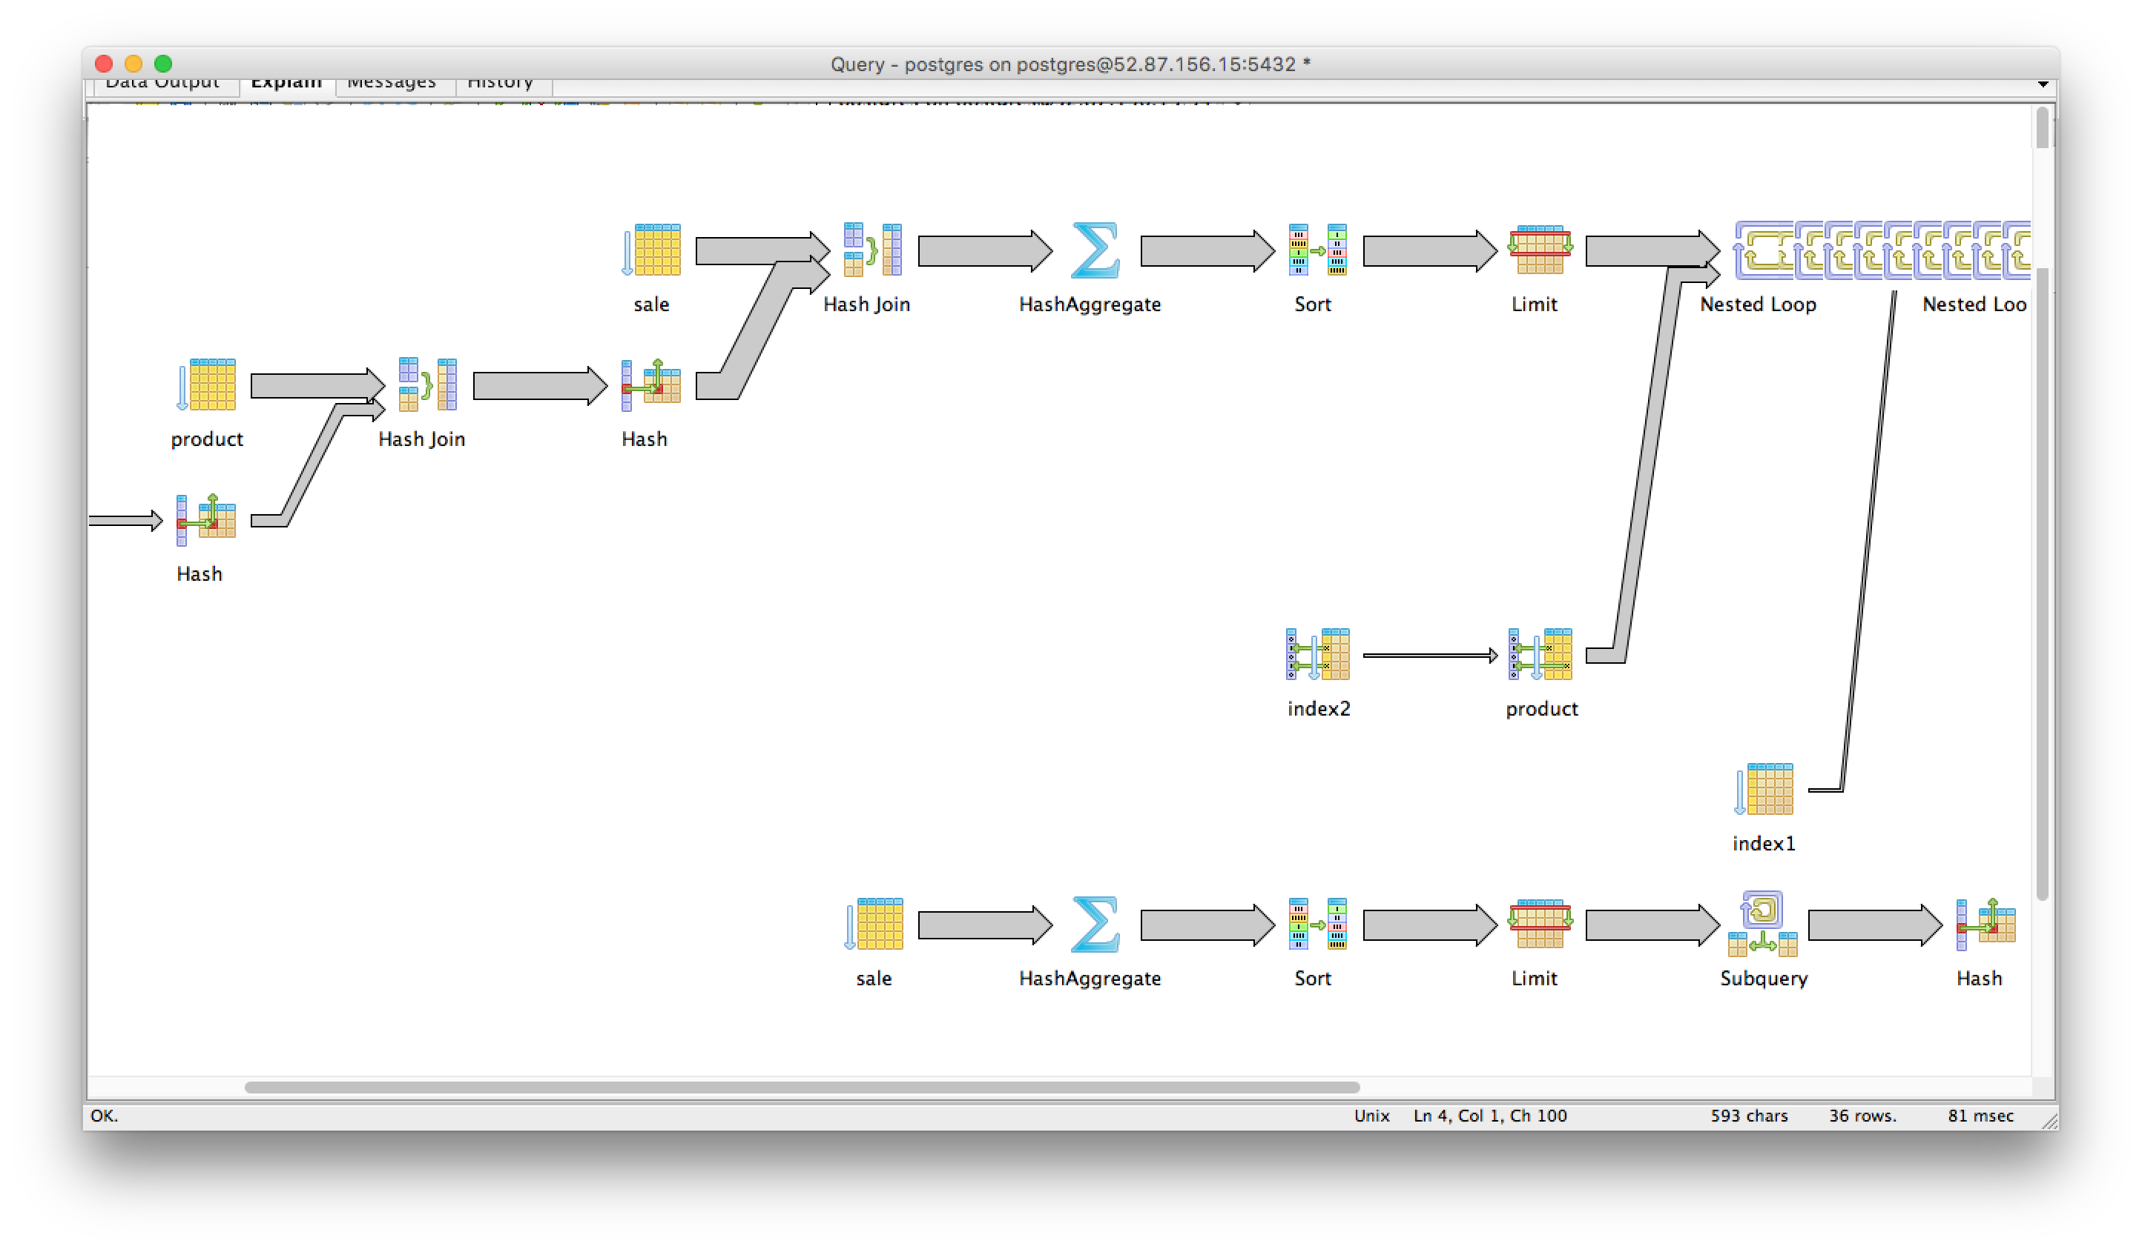

Cats

1) ## No place to put the index here because there is no where or join clause
2)
##Cost with no indexes created
"Limit (cost=107391.36..107391.39 rows=10 width=4)"
# Reduced cost with Index on user_id in the friends table
CREATE INDEX index1 ON cats.friend(user_id);
"Limit (cost=73619.53..73619.56 rows=10 width=4)"

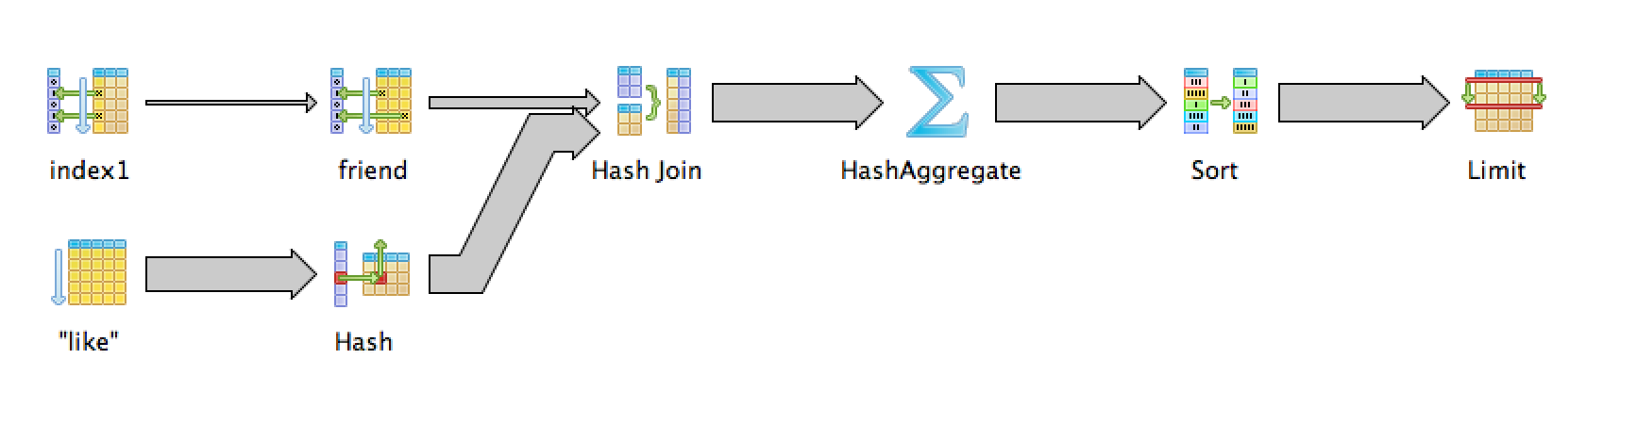
## 3)
##Cost with no indexes created
"Limit (cost=284830.76..284830.79 rows=10 width=4)"
## Reduced Cost With Indexes Created on user_id in the friends table
"Limit (cost=152067.65..152067.68 rows=10 width=4)"
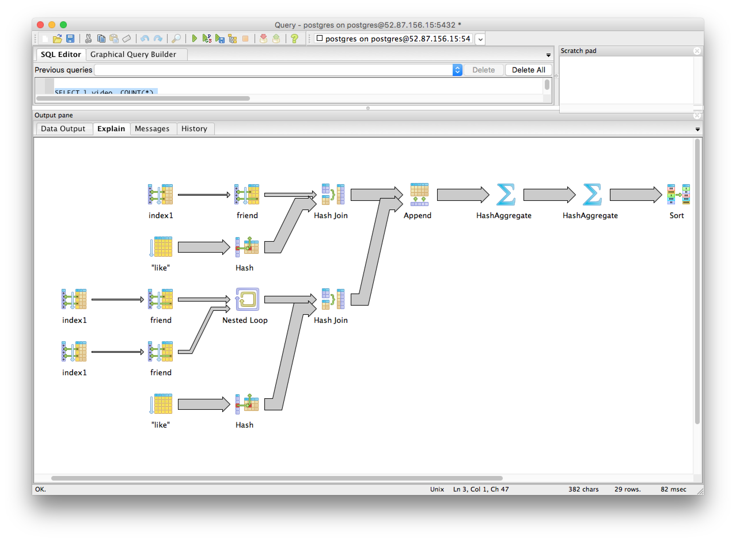
## 4)
##Cost with no indexes
"Limit (cost=214655.54..214655.57 rows=10 width=4)"
## Cost was reduced with indexes on the like table for user ID
CREATE INDEX index1 ON cats.like(user_id);
"Limit (cost=186603.76..186603.79 rows=10 width=4)"
##Cost with indexes created on video_id of the like table, this didn't show any improvements over the user_id
CREATE INDEX index2 ON cats.like(video_id);
## cost with both
CREATE INDEX index1 ON cats.like(user_id);
CREATE INDEX index2 ON cats.like(video_id);
"Limit (cost=186603.76..186603.79 rows=10 width=4)"
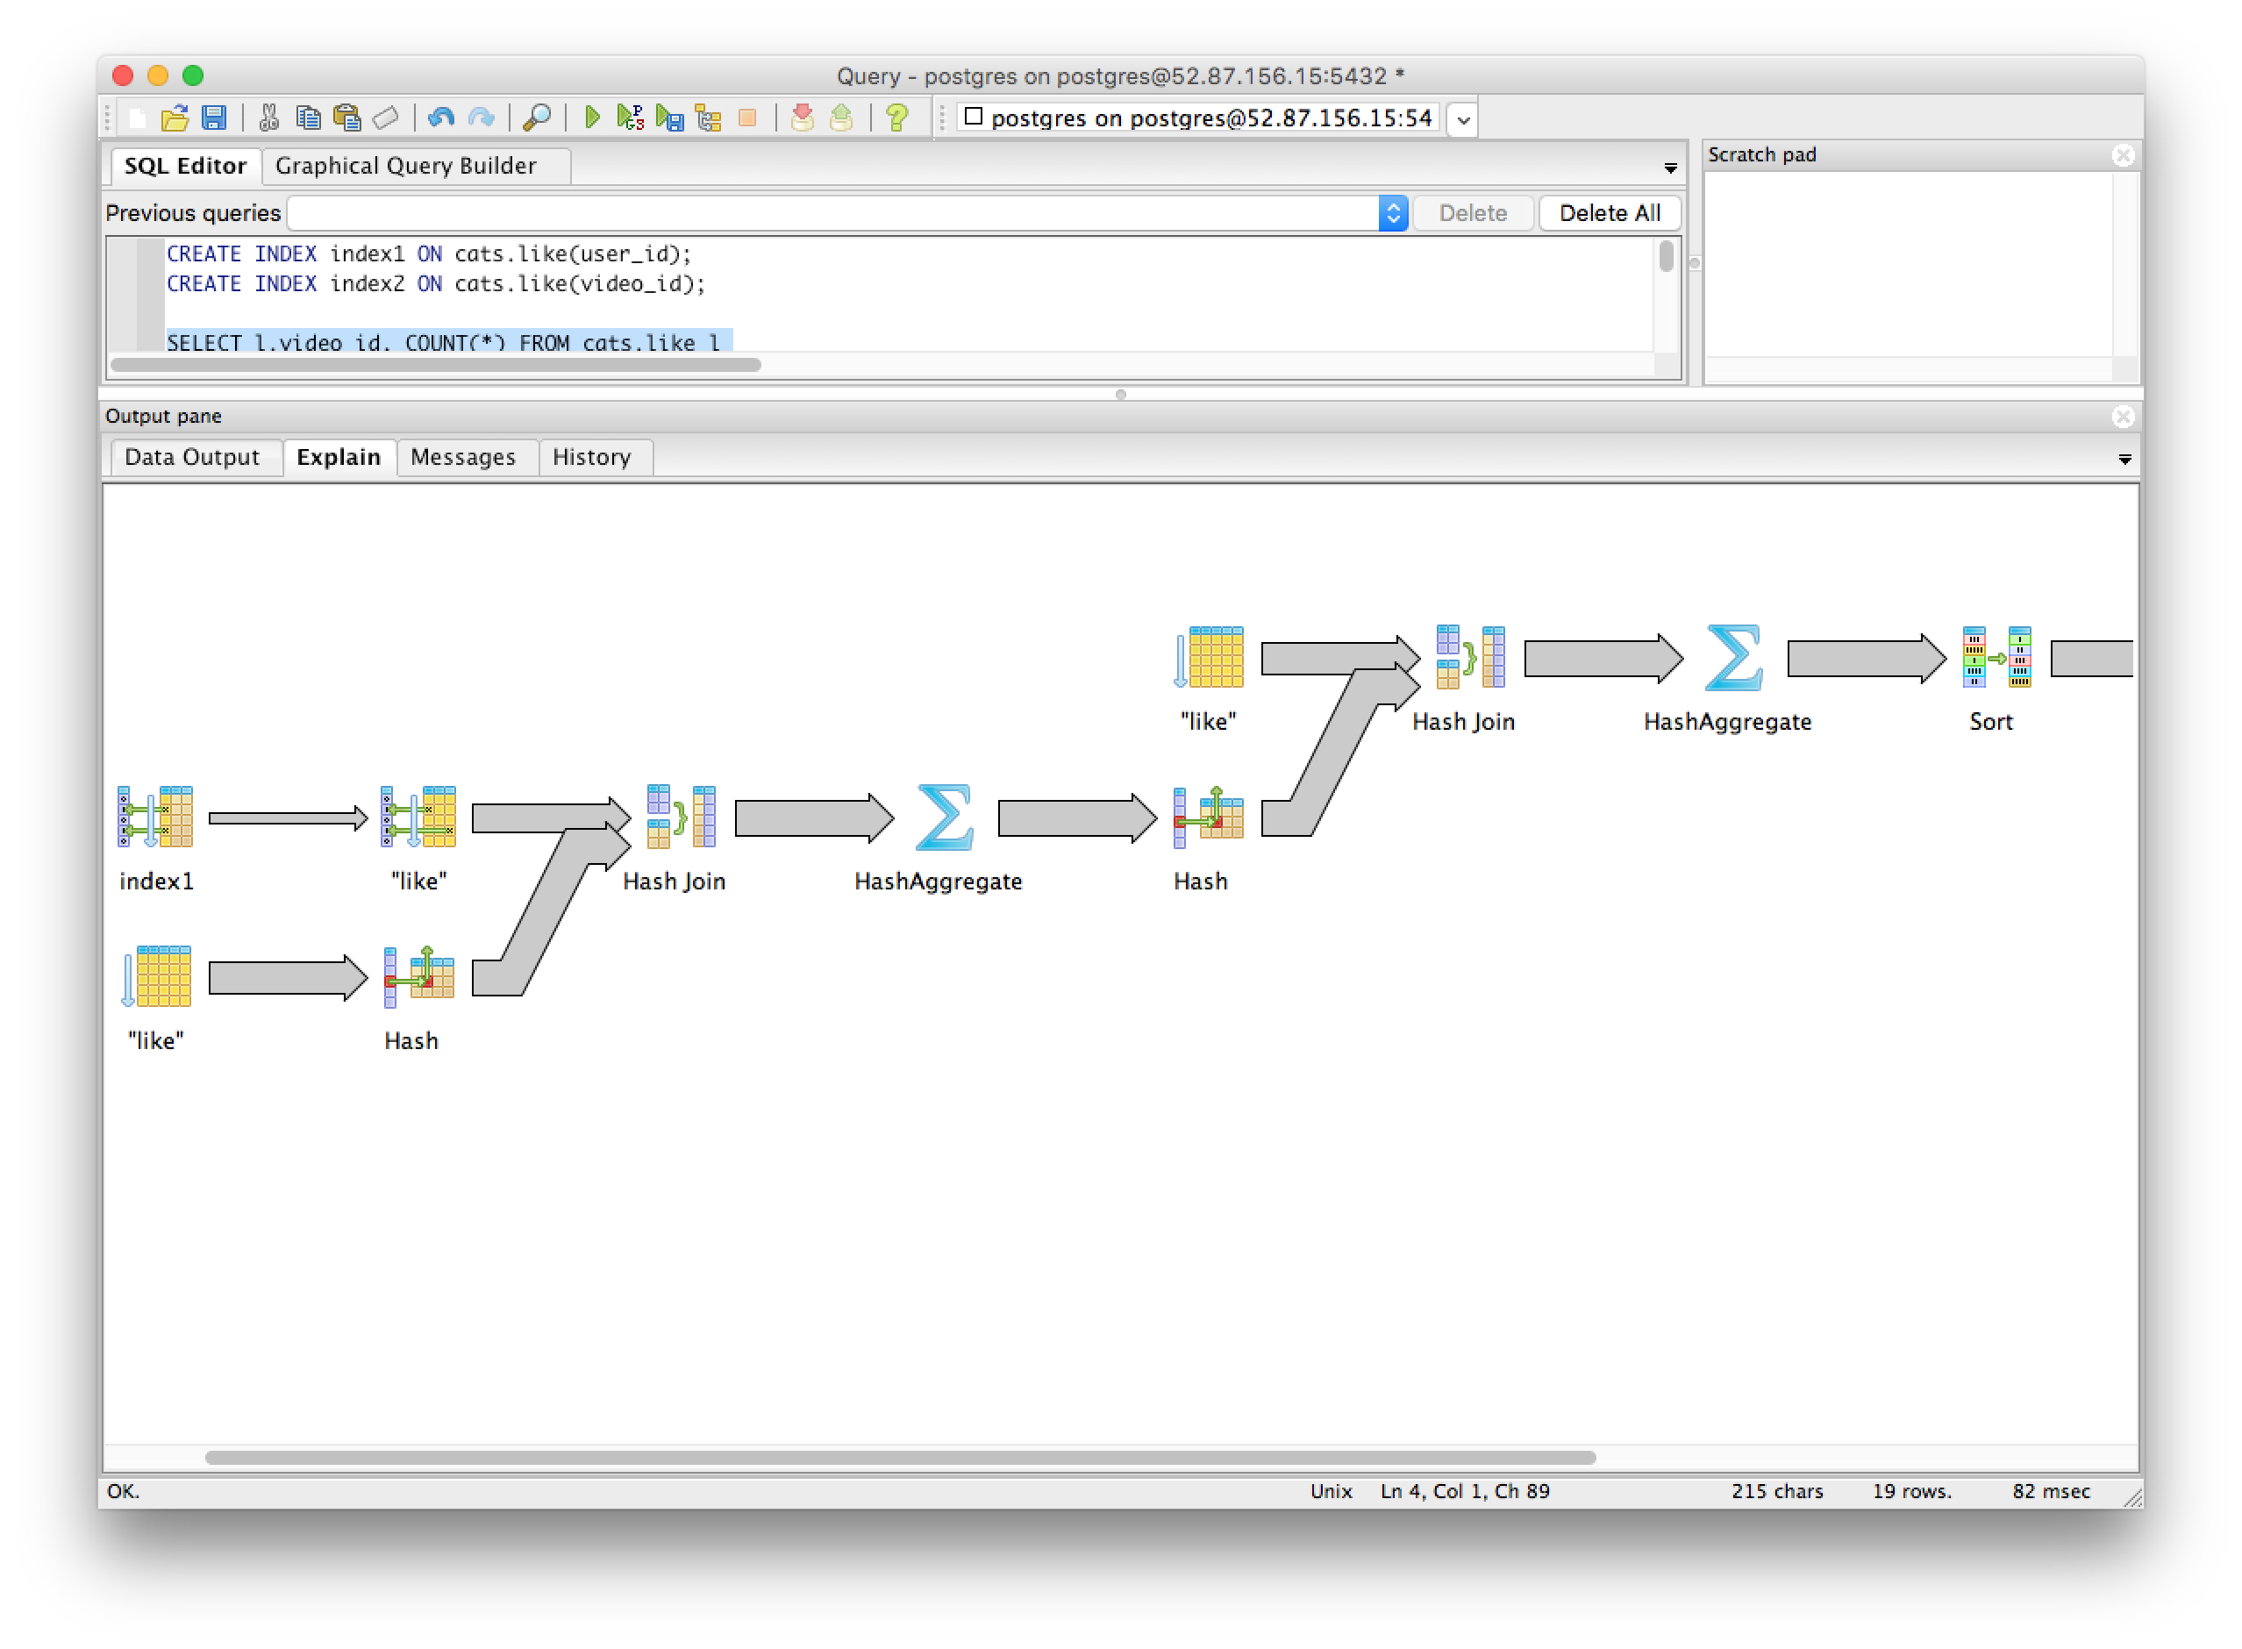
## 5)
## Cost of queries with no indexes
"Limit (cost=256169.77..256169.80 rows=10 width=12)"
## reduced cost of queries with indexes on the like_user
CREATE INDEX index1 ON cats.like(user_id);
"Limit (cost=228117.99..228118.02 rows=10 width=12)"

